**BASH SCRIPTING:- To remove the manual work and automate the process through script**



**1. Creating script for executing bash command**

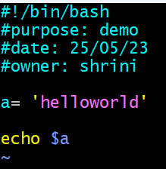 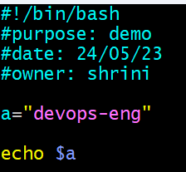

{#!} she bang

{/bin/bash} it shows which shell we are using

# :- comments for giving message

{a=”devops-eng”} it is variable it makes our changes more genric

echo $a To show the variable content/to call out the variable we use “$”





**2 .Trying diff commands with the script**

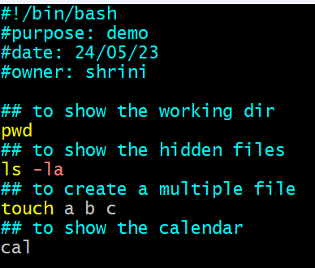

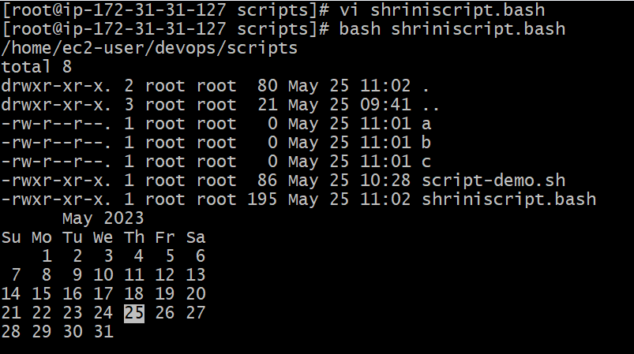

**3. Trying to execute with diff commands by bash scripting**

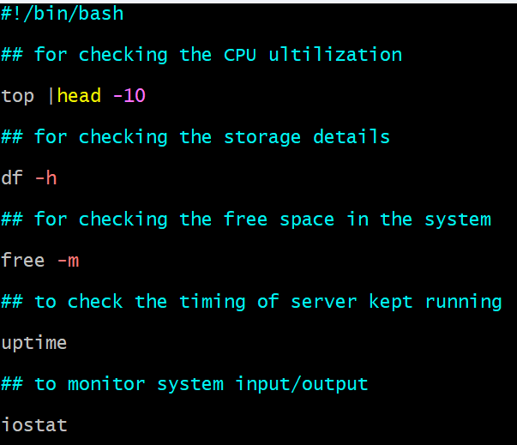

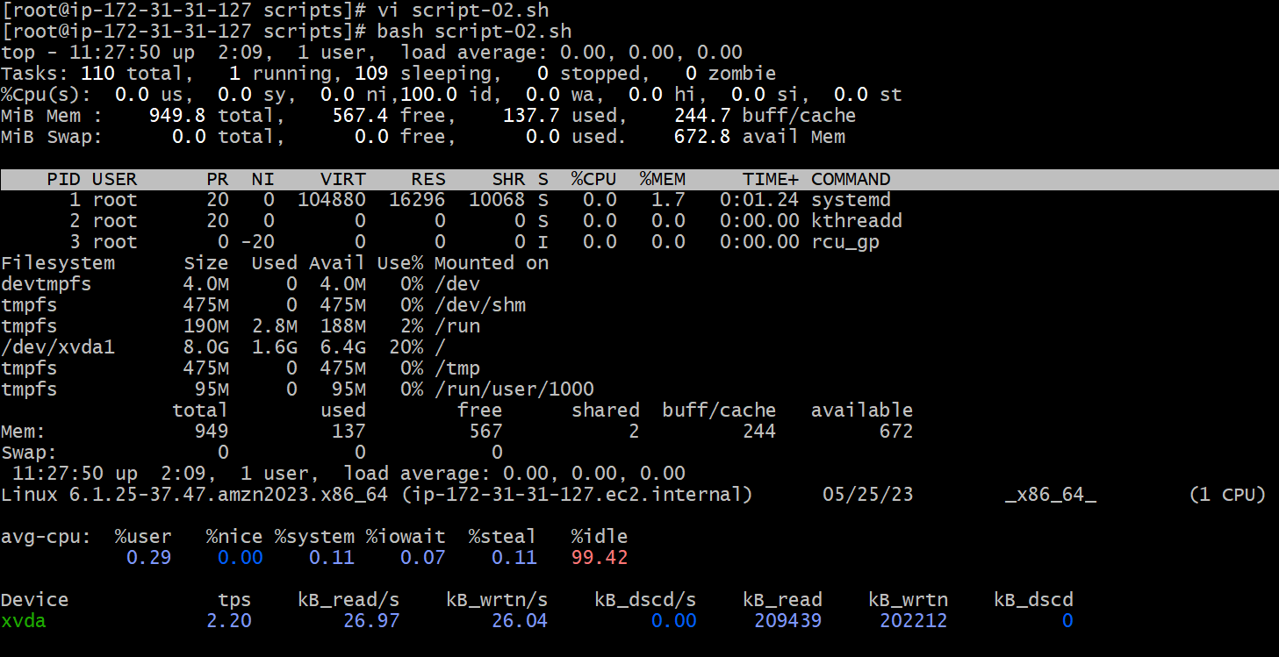

**With the bash command we can execute the file without giving permissions**

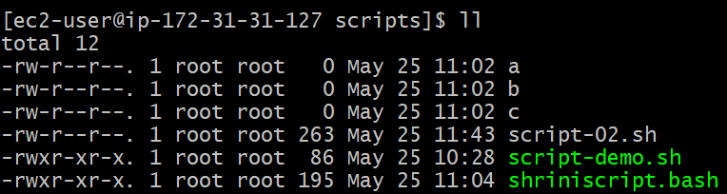

**4. Creating a script with different variables**

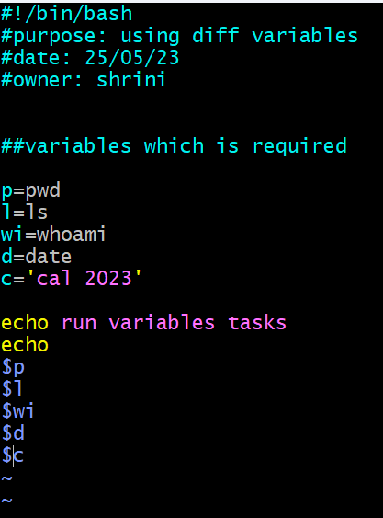.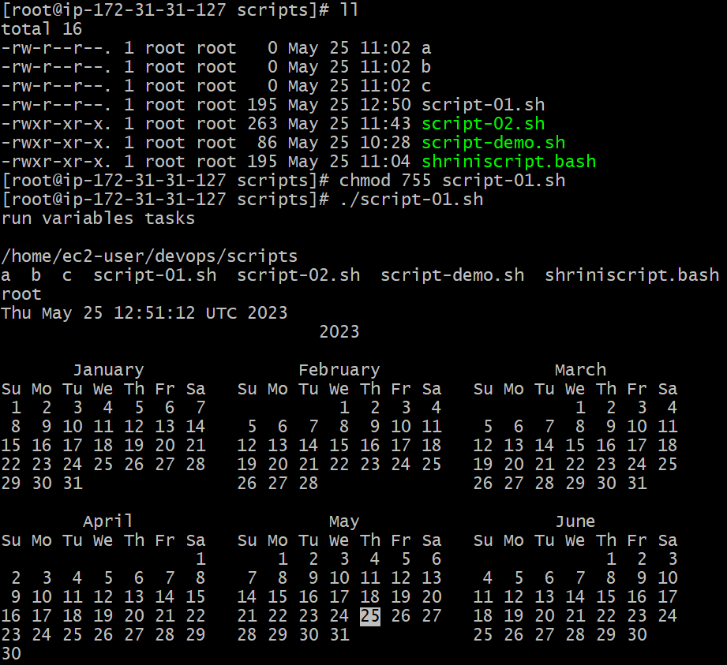

**5. Creating a bash script to show the system name and using tick mark**

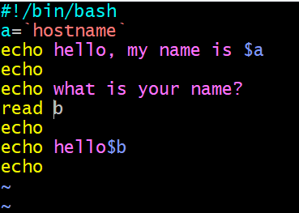

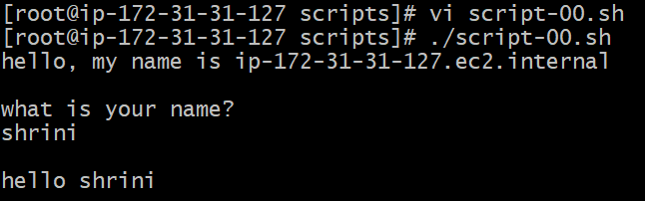

**Condition for “ if “ with different parameter**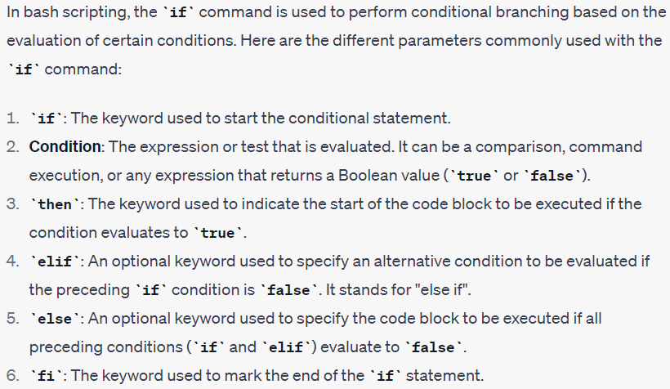  
**6. Creating script for greater than lower than or equal**

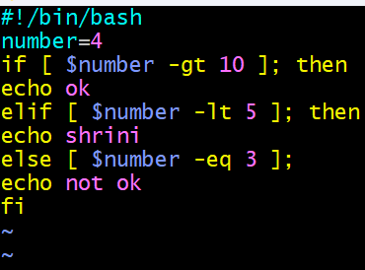

**7. if file find-out condition with script**

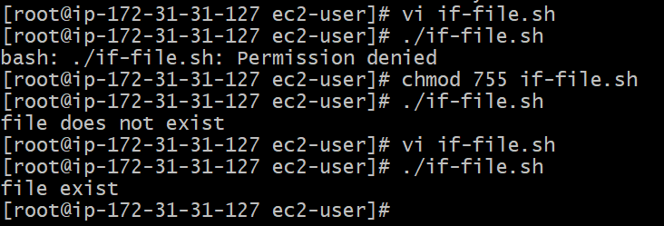

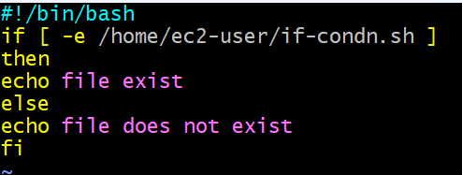

8. “scp” command use-case

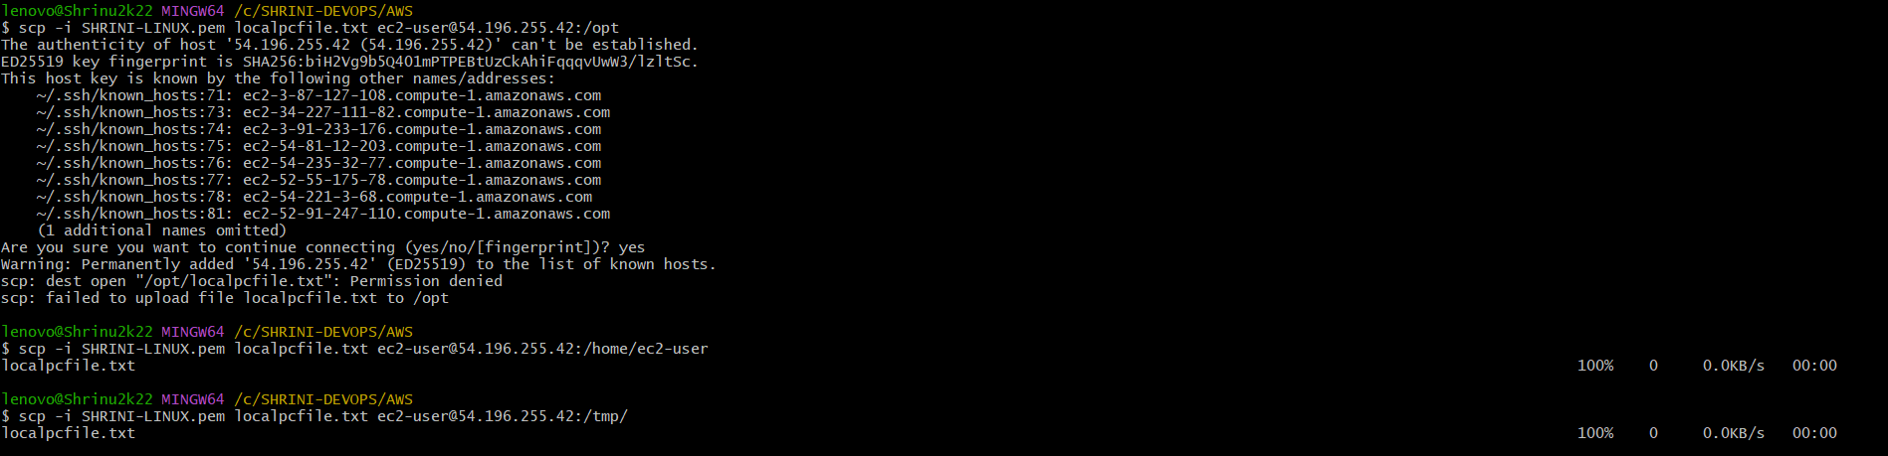

9. FOR loop­­­ commands how many times variables has been assigned for   
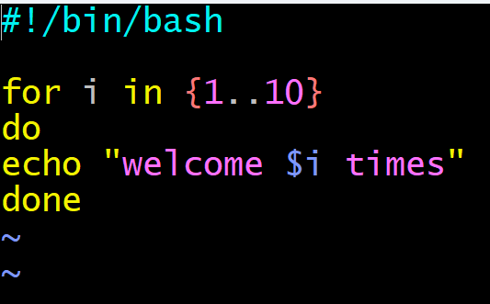

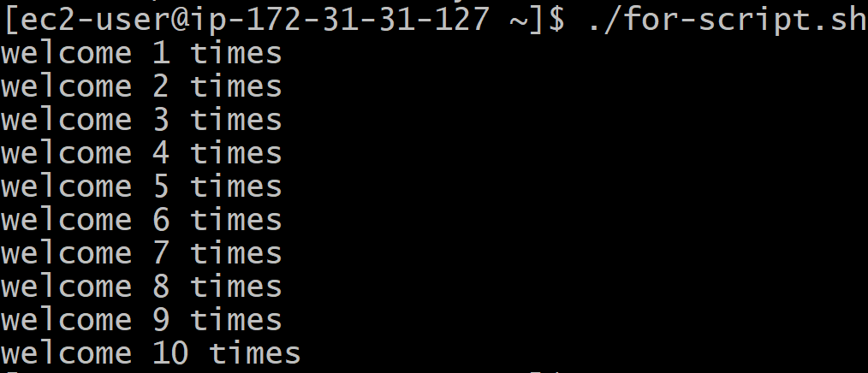

10. TO check the previous command status

